How to login to Microsoft Teams
Step 1

Type www.office.com into your browser and Click on the sign in button.

Sign in with the username and password that was emailed to your parents/carers.
We recommend you use the web app when prompted rather than Get the Windows App

Step 2

Click on the Teams icon which can be found either on the left hand side or at the top.

How to open, edit and submit an assignment in Microsoft Teams
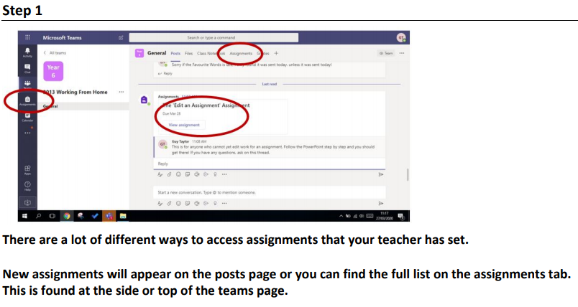
Step 1

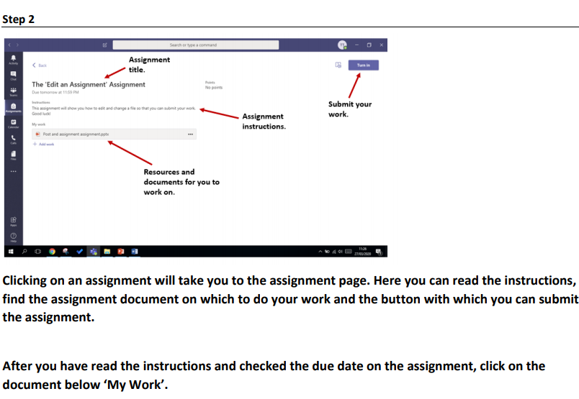
Step 2

Step 3
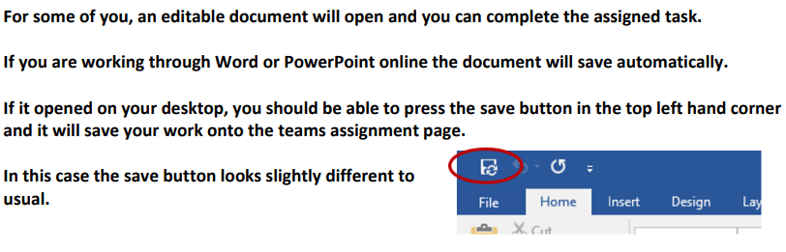

If you can not edit the document move on to step 4, don’t worry you are nearly there!
Step 4
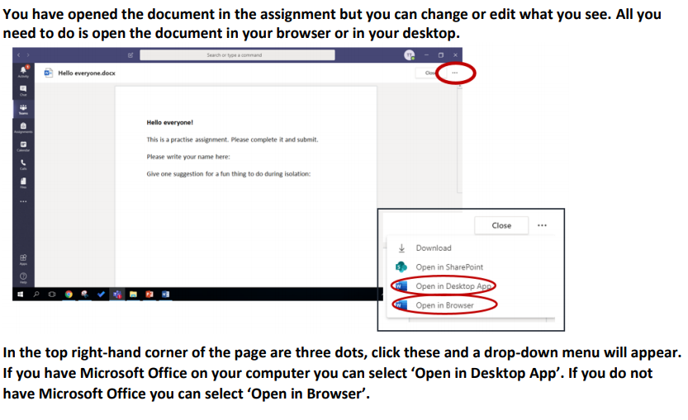

Step 5
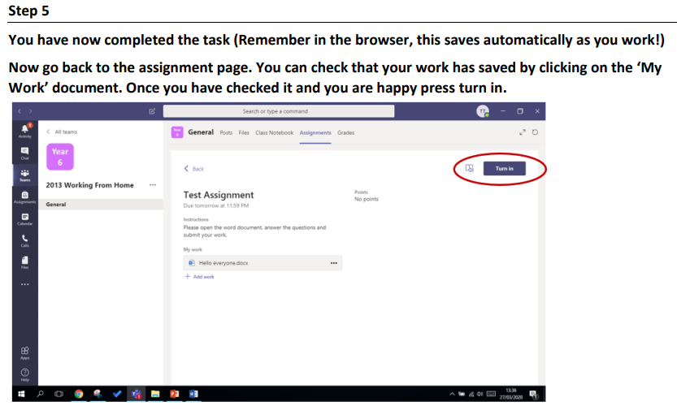

Step 6
