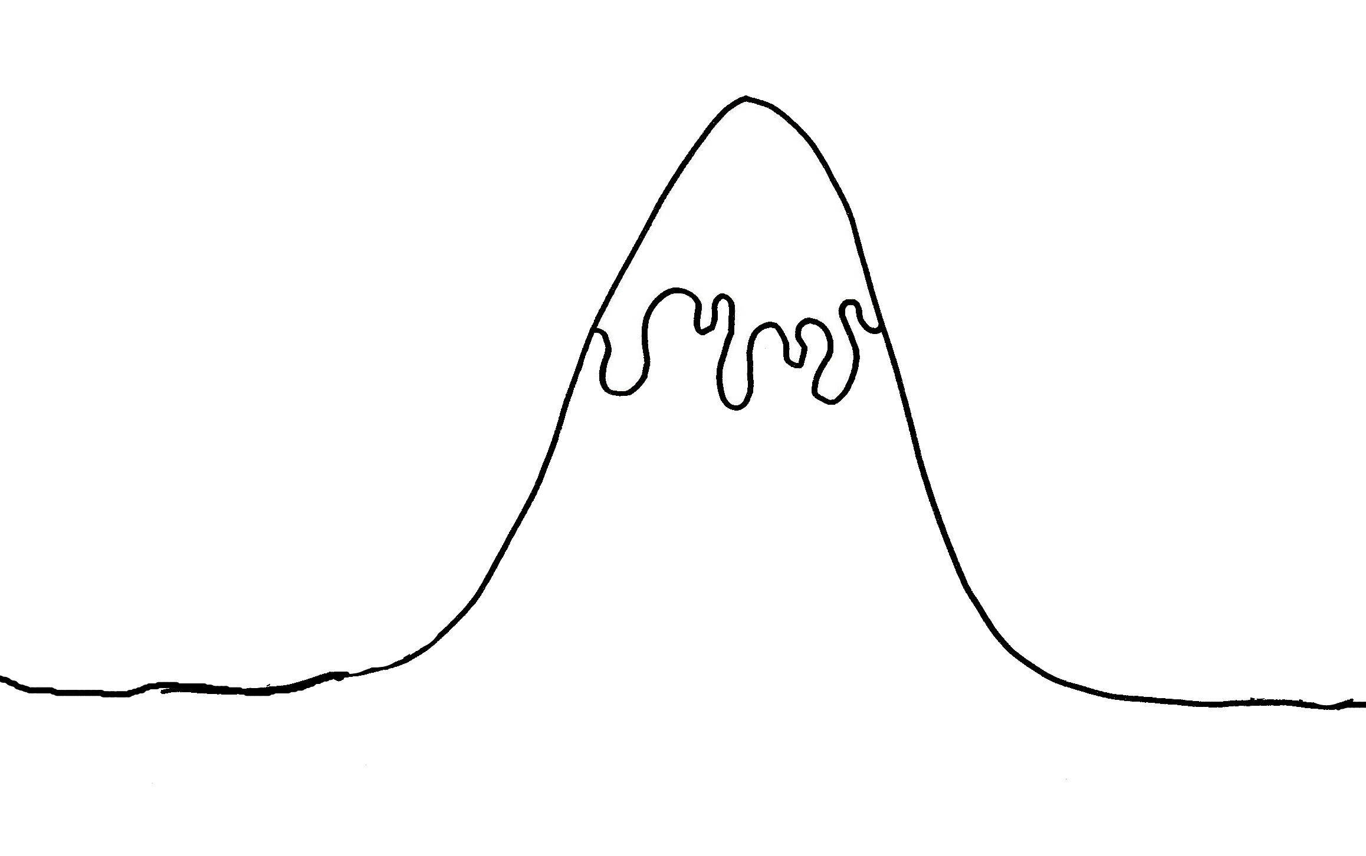

Is the problem fixed once and for all?

Have the main characters learnt anything?

What is the moral of the story?

**Story Mountain**

What is the main problem in the story or the problems that the main characters have to overcome?

Who are the main characters?

Describe the setting.

**Ending**

How do the characters fix the problem?

Does anyone come to help?

What has changed?

What are the characters thinking and feeling when they face the problem?

**Problem!**

___________________________________________________________

**Ending**

____________________________________________________________

**Fix problem**

______________________________________________________________________________________________________

**Problem!!**

_______________________________________________________________

**Introduction**

Who:____________________Where:___________________________________________________-

**Build up**

____________________________________________________________________________________________________________________________________________

**Fix problem**

______________________________________________________________________________________________________

**Introduction**

Who:____________________Where:___________________________________________________-

**Build up**

____________________________________________________________________________________________________________________________________________