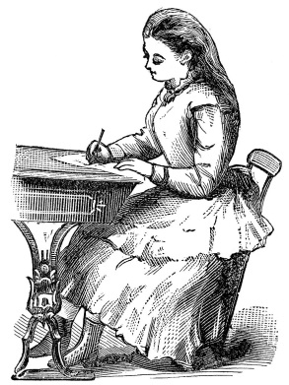
Victorian schools
This text has been written for a Victorian child to help them on their first day at school. Choose your challenge and complete the activity you have been asked to do.

a victorian school is very strict to make sure that you do well at school follow these instructions
carefully remember teachers do not encourage children to talk share their ideas or ask questions
you will need a hat some smart clothes and lunch if you live too far away to get home for lunch
first make sure that you arrive on time children who are late get in a lot of trouble next stand
up when the teacher enters the room after that make sure that you only write with your right
hand even if you are left handed then make sure that you only put up your hand if you are told
to finally remember to call your teacher sir or ma’am if you follow these simple rules you may be
able to get through your first day without being caned

